Patient symptom submission & triage
by 22L-6979, 22L-6684

Business Identification
Company Name: MediFlow AI.
Business Nature: A HealthTech startup specializing in AI-assisted diagnostic tools for small-to-medium clinics.
Project Goal: Developing an automated "Smart Triage" system to analyze patient symptoms via a mobile app and prioritize urgent cases.
Current system:

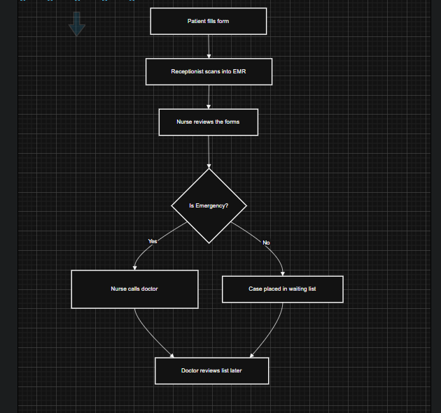

Problems in the current manual triage system

- Paper based intake forms must be scanned and entered into the EMR, creating transcription delays and error prone data.

- Nurses perform a subjective, handwritten urgency assessment, leading to inconsistent prioritization and possible mistriage.

- Emergency cases are only flagged after a nurse to doctor hand off, so critical patients can wait minutes to hours before receiving attention.

- No automatic audit trail exists, making it difficult to track who made the decision or to analyze performance.

- Overall patient wait time is long; the business goal is to cut it by ≈ 40 % (indicating the current system falls far short).

Improved system:

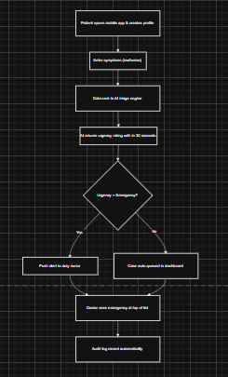

Improvements introduced by the Smart Triage system

- Patients submit symptoms directly through a secure mobile app, eliminating paper handling and manual data entry.

- An AI engine returns an urgency rating (Emergency/Urgent/Routine) within ≤ 30 seconds, providing rapid, objective prioritization.

- Emergency alerts are pushed instantly to the duty nurse, so critical cases are acted on immediately.

- The dashboard auto queues non-emergency cases and highlights emergencies at the top, standardizing workflow for clinicians.

- All actions are logged automatically, creating a complete audit trail for quality management and compliance.

- The system targets a ≥ 95 % correct identification of high risk “Emergency” keywords, improving patient safety and reducing wrong diagnosis risk.

- By removing manual steps and bottlenecks, the smart solution is expected to reduce overall wait times by about 40 % and increase clinic efficiency.

